**Lab 1**

**Introduction**

C is a general-purpose programming language. It is useful for writing compilers and operating systems; it has been used equally well to write major programs in many different domains.

**Example: 1**

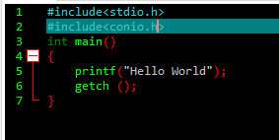

#include<stdio.h> and #include<conio.h> are the preprocessor commands provided by the c language itself. After writing this program the output will be

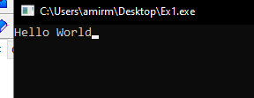

**Example: 2**

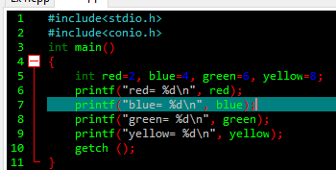

The output will be:

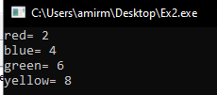

**Example: 3 (Arithmetic operators)**

The binary arithmetic operators are +, -, *, /, and the modulus operator %.

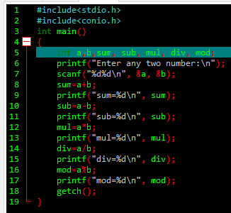

The output will be:

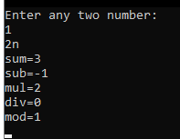

**Example: 4 (Assignment operators)**

The operator += is called assignment operator.

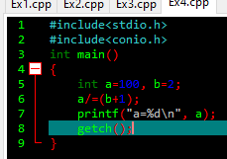

The output will be:

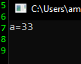

**Example: 5 (Conditional or Ternary operator)**

X=(a<b)? a: b; is conditional or ternary operator.

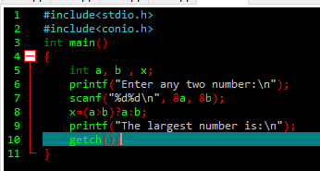

The output will be:

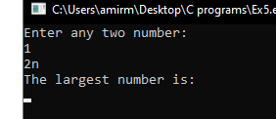

**Example: 6 (Special operators)**

C supports some special operators of interest such as comma operator, size of operator, pointer operators (& and *) and member selection operators (. and ->).

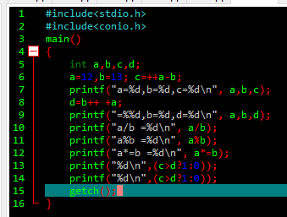

The output will be:

